USP5 Computational Project Report
Mentor-facing summary of the modeling, enumeration, and lead selection workflow
Generated on 2026-04-01

Executive Summary
- The project now has one canonical computational pipeline built around a saved ExtraTrees regression model, a broad 10-method enumeration library, and a multistage lead-selection funnel.
- The final saved potency model achieved in-sample R^2 = 0.893 on the current row-level USP5 dataset and remains the project-level potency engine.
- The broad enumeration workflow produced 3264 unique virtual compounds from the positive training chemistry space.
- The final screening pipeline narrowed 3274 total structures (broad enumeration plus original positives) to a 6-compound non-ZnF primary set and 4 additional orthogonal backups.
- The primary-lead logic was intentionally changed so the final list no longer favors the ZnF-UBD-like CHEMBL5278336 series and instead rewards novelty relative to both the existing dataset and known ZnF-reference chemistry.
- Most computational cheminformatics work is complete; the main remaining tasks before paper writing are figure assembly, polished results framing, and ideally experimental validation planning.

Project Aim
The goal of this project is to build a practical small-data USP5 inhibitor discovery workflow that combines potency modeling, chemically meaningful virtual enumeration, and computational lead prioritization. The emphasis is on transparent and interpretable cheminformatics rather than black-box modeling.

Dataset Status
- Raw input file: data/raw/First.csv
- Valid row-level entries used by the final model: 26
- Deduplicated canonical molecules in the modeling table: 19
- The dataset mixes measured activity rows with assigned active/inactive labels; this is tracked explicitly in the cleaned outputs.

Modeling Dataset Overview
representative_id | target_pIC50 | target_origin | has_measured_row | has_active_no_ic50_row | has_inactive_row
CHEMBL5278336 | 5.15 | measured_median | True | False | False
CHEMBL1410015 | 4.62 | measured_median | True | False | False
CHEMBL2012938 | 5.23 | mixed_duplicate_measured_median | True | True | False
CHEMBL1923233 | 5.52 | measured_median | True | False | False
CHEMBL5276142 | 4.67 | measured_median | True | False | False
CHEMBL1493046 | 4.54 | measured_median | True | False | False
CHEMBL4635160 | 5 | measured_median | True | False | False
CHEMBL5410606 | 5.1 | measured_median | True | False | False
CHEMBL5267683 | 3.7 | measured_median | True | False | False
CHEMBL4129140 | 3.7 | measured_median | True | False | False
51031028 | 2.5 | assigned_median | False | False | True
443118 | 2.5 | assigned_median | False | False | True
10216098 | 2.5 | assigned_median | False | False | True
49864402 | 2.5 | assigned_median | False | False | True
25191039 | 5 | assigned_median | False | True | False
70691637 | 5 | assigned_median | False | True | False
73353602 | 2.5 | assigned_median | False | False | True
145963683 | 5 | assigned_median | False | True | False
168007234 | 2.5 | assigned_median | False | False | True

Final Potency Model
The final potency model is the saved ExtraTreesRegressor reported in outputs/final_model/final_model_report.md. This model was deliberately preserved as the canonical project model for all final screening.
- Model family: ExtraTreesRegressor
- Feature block: physicochemical descriptors plus graph-topology descriptors
- Reported in-sample R^2: 0.893359
- Reported MAE: 0.176795
- Reported RMSE: 0.368224
- Model artifact: outputs/final_model/final_model.joblib
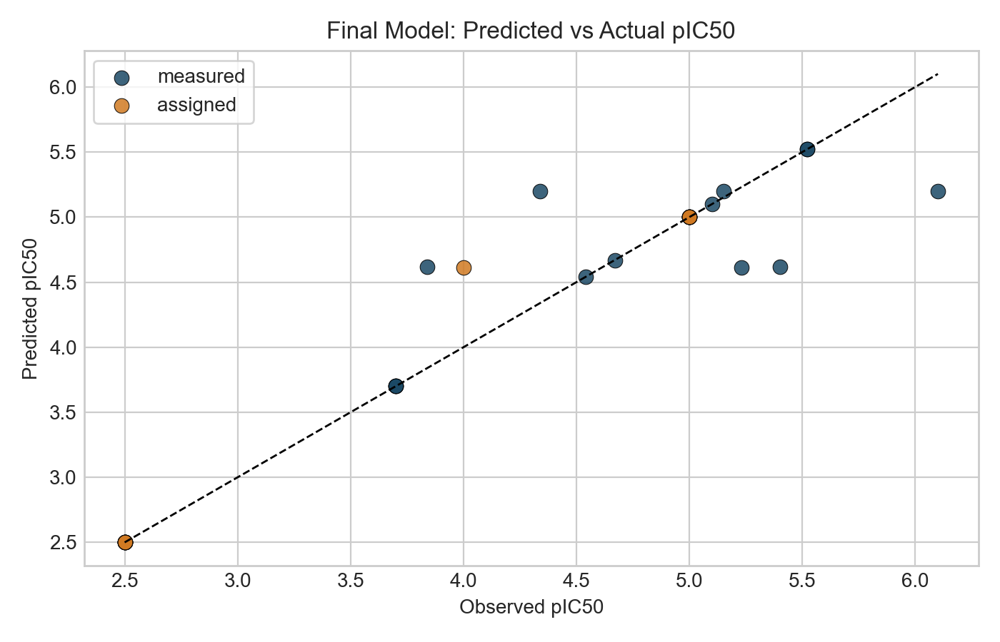
Final model predicted vs observed pIC50
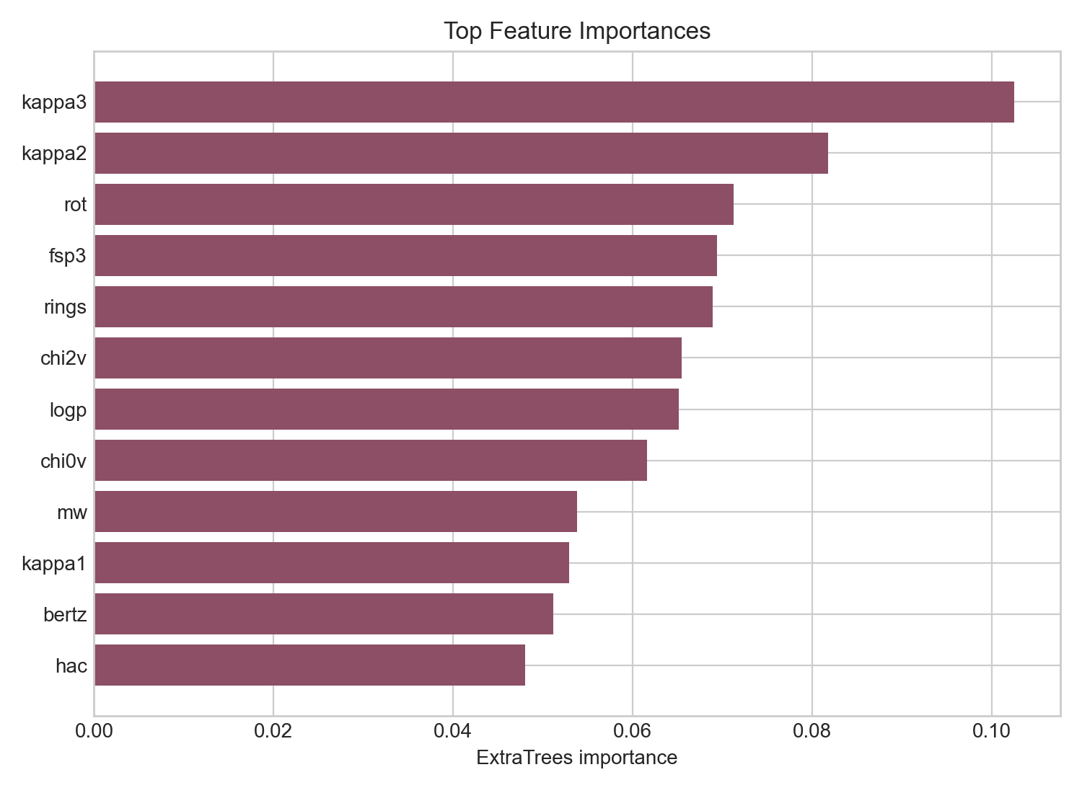
Top feature importances in the final model

Enumeration Workflow
The final enumeration layer is the broad 10-method chemistry workflow. This is the canonical virtual library generation stage used for downstream lead screening.
- Canonical enumeration script: scripts/run_enumeration_10_methods.py
- Canonical broad library: outputs/enumeration_library_10_methods.csv
- Total unique enumerated products: 3264

Enumeration Method Breakdown
method | count
r_group_enumeration | 1205
reagent_pool_combinatorics | 1200
scaffold_hopping | 671
fragment_growing | 430
heteroatom_walks | 61
reaction_based_enumeration | 31
matched_molecular_pair_expansion | 25
bioisosteric_swaps | 15
linker_scans | 5
ring_size_and_ring_system_scans | 3

Final Lead Selection Workflow
The canonical lead-selection workflow restores the saved final ExtraTrees model as the sole potency engine, then applies property filtering, ADMET-AI, and a final novelty-driven prioritization step that explicitly deprioritizes ZnF-UBD-like chemistry.
- Canonical screening script: scripts/run_lead_selection.py
- Property filters include Lipinski-style limits, TPSA, molecular surface area, flexibility, and charge sanity.
- ADMET stage uses ADMET-AI with AMES, hERG, ClinTox, HIA, oral bioavailability, permeability, and solubility-related outputs.
- The final prioritization stage now penalizes similarity to known ZnF-reference ligands and filters out original known molecules from the primary-lead set.
- The final output is split into a non-ZnF primary set, orthogonal backups, and a separately saved deprioritized ZnF-like pool.

Lead Selection Funnel
stage | count
start_broad_enumeration_plus_original_positives | 3274
stage1_original_final_model_predicted_pIC50_ge_4.60 | 1272
stage2_pains_brenk_free | 772
stage3_lipinski_psa_surface_area_flexibility | 59
stage4_admet_ai_multigate | 24
stage5_non_znf_and_not_original | 18
stage5b_non_znf_relaxed_pool | 19

Primary Leads

Canonical Primary Lead Set
product_smiles | primary_parent_id | pred_pIC50 | pred_ic50_uM | AMES | hERG | max_similarity_to_existing | max_similarity_to_znf_reference | orthogonal_composite_score | scaffold
COc1ccccc1CNC(=O)Cn1c(CCC(=O)O)nc2c(F)cccc2c1=O | CHEMBL5410606 | 5.0192 | 9.5668 | 0.1279 | 0.1607 | 0.8125 | 0.2022 | 0.7428 | O=C(Cn1cnc2ccccc2c1=O)NCc1ccccc1
Cc1cc(-n2c(C)cc(CCC(=O)O)c2C)c(C)n1CCC(=O)O | [9*]n1c(C)cc([16*])c1C | 4.8758 | 13.3097 | 0.0681 | 0.0676 | 0.2295 | 0.1857 | 0.6583 | c1ccn(-c2cc[nH]c2)c1
COc1ccncc1CNC(=O)Cn1c(CCC(=O)O)nc2c(Cl)cccc2c1=O | CHEMBL5410606 | 4.8761 | 13.3004 | 0.0303 | 0.1776 | 0.8182 | 0.1915 | 0.6403 | O=C(Cn1cnc2ccccc2c1=O)NCc1cccnc1
Cc1cc(-c2cc(C)n(CCC(=O)O)c2C)c(C)n1CCC(=O)O | [9*]n1c(C)cc([16*])c1C | 4.8743 | 13.3562 | 0.0932 | 0.1127 | 0.2264 | 0.2167 | 0.6396 | c1cc(-c2cc[nH]c2)c[nH]1
CC(=O)C1=C(O)C(=O)N(CCC(=O)O)C1c1ccc(Cl)cc1 | CHEMBL4129140 | 4.9085 | 12.3456 | 0.0322 | 0.0299 | 0.5273 | 0.2571 | 0.5966 | O=C1C=CC(c2ccccc2)N1
CC(=O)C1=C(O)C(=O)N(c2ccc(O)cc2)C1c1ccc(Cl)cc1 | CHEMBL4129140 | 4.8777 | 13.2521 | 0.0935 | 0.2238 | 0.4068 | 0.2254 | 0.5781 | O=C1C=CC(c2ccccc2)N1c1ccccc1

Orthogonal Backup Leads

Canonical Backup Lead Set
product_smiles | primary_parent_id | pred_pIC50 | AMES | hERG | max_similarity_to_existing | max_similarity_to_znf_reference | orthogonal_composite_score | scaffold
COc1ccccc1CNC(=O)Cn1c(CCC(=O)O)nc2c(Cl)cccc2c1=O | CHEMBL5410606 | 5.1 | 0.1284 | 0.2254 | 1 | 0.1868 | 0.7123 | O=C(Cn1cnc2ccccc2c1=O)NCc1ccccc1
COc1ncccc1CNC(=O)Cn1c(CCC(=O)O)nc2c(Cl)cccc2c1=O | CHEMBL5410606 | 4.8761 | 0.0736 | 0.0731 | 0.7879 | 0.1957 | 0.5719 | O=C(Cn1cnc2ccccc2c1=O)NCc1cccnc1
CC(=O)C1=C(O)C(=O)N(c2ccccc2)C1c1ccc(Cl)cc1 | CHEMBL4129140 | 4.8639 | 0.0442 | 0.1758 | 0.4068 | 0.2429 | 0.5152 | O=C1C=CC(c2ccccc2)N1c1ccccc1
CC(=O)C1=C(O)C(=O)N(c2ccc(F)cc2)C1c1ccc(Cl)cc1 | CHEMBL4129140 | 4.8347 | 0.0576 | 0.197 | 0.3934 | 0.2192 | 0.5054 | O=C1C=CC(c2ccccc2)N1c1ccccc1

Deprioritized ZnF-Like Pool
The compounds below still score well on potency and basic developability, but they are intentionally removed from the primary program because they are too close to the previously favored ZnF-UBD-like chemistry.

Deprioritized ZnF-Like Examples
product_smiles | primary_parent_id | pred_pIC50 | max_similarity_to_existing | max_similarity_to_znf_reference | orthogonal_composite_score
O=C(O)CNC(=O)c1ccc(S(=O)(=O)N2CCC(c3ccc(Cl)cc3)CC2)cn1 | CHEMBL5278336 | 5.1967 | 1 | 1 | 0.67
COc1ccccc1CNC(=O)Cn1c(CCC(=O)O)nc2c(Cl)cccc2c1=O | CHEMBL5410606 | 5.1 | 1 | 0.1868 | 0.5504
O=C(O)CNC(=O)c1ccc(S(=O)(=O)N2CCC(c3ccc(F)cc3)CC2)cn1 | CHEMBL5278336 | 5.011 | 0.8364 | 0.8364 | 0.397
O=C(O)CNC(=O)c1ncc(S(=O)(=O)N2CCC(c3ccc(Cl)cc3)CC2)cn1 | CHEMBL5278336 | 4.8951 | 0.8 | 0.8 | 0.2584
O=C(O)CNC(=O)c1ccc(S(=O)(=O)N2CCC(c3ccc(Cl)cn3)CC2)cn1 | CHEMBL5278336 | 4.895 | 0.7895 | 0.7895 | 0.2753
O=C(O)CNC(=O)c1cnc(S(=O)(=O)N2CCC(c3ccc(Cl)cc3)CC2)cn1 | CHEMBL5278336 | 4.895 | 0.7719 | 0.7719 | 0.2399

Interpretation of Current Results
- The primary lead set is no longer concentrated in the CHEMBL5278336 ZnF-UBD-like acid-sulfonamide family.
- The current primary program is distributed across CHEMBL5410606-derived bicyclic carbonyl analogs, a compact heteroaryl-acid branch, and CHEMBL4129140-derived cyclic diketone analogs.
- This makes the project story more orthogonal and less dependent on a mechanism your mentor specifically wanted deprioritized.
- The project now has a consistent folder structure and a single final pipeline rather than multiple competing screening variants.
- From a project-management standpoint, most of the computational chemistry work is now done.

Limitations
- The final model is exploratory and small-data; strong prospective claims should be avoided.
- The final model performance reported here is in-sample rather than a large prospective benchmark.
- All lead calls remain computational priorities until experimentally tested.
- The dataset includes assigned labels in addition to measured values, which should be acknowledged in any presentation or manuscript.
- Novelty filtering is useful for strategic triage, but it does not itself prove biological relevance.

Work Completed
- Dataset parsing, cleaning, label annotation, and canonicalization
- Descriptor and fingerprint generation
- Baseline similarity and scaffold analysis
- Final exploratory USP5 potency model selection and report generation
- Broad 10-method combinatorial enumeration
- ADMET-AI integration
- Non-ZnF novelty-aware lead reprioritization against existing and ZnF-reference chemistry
- Primary, orthogonal backup, and deprioritized ZnF-like lead partitioning
- Project-folder cleanup and canonical final pipeline consolidation

What Remains Before Paper Writing
- Assemble publication-quality figures from the existing outputs
- Freeze the exact final tables and figure order for the manuscript
- Write the Results and Discussion around the canonical final pipeline
- State limitations carefully and explicitly
- Ideally plan or begin experimental validation to strengthen the paper

Key Project Files
Canonical project summary: outputs/final_pipeline_summary.md
- outputs/lead_selection_summary.md
- outputs/final_leads.csv
- outputs/backup_leads.csv
- outputs/deprioritized_znf_like_pool.csv
- outputs/enumeration_library_10_methods.csv
- outputs/final_model/final_model_report.md

Appendix: Internal Text Summaries
The following brief snippets capture the current canonical pipeline and final-model summaries from the project files.

Final pipeline summary
# Final Canonical USP5 Pipeline
This project now uses one canonical end-to-end computational workflow.
## Final model
- Potency model: saved `ExtraTreesRegressor`
- Model artifact: [final_model.joblib](/Users/shivanshsahni/Documents/New%20project/outputs/final_model/final_model.joblib)
- Model report: [final_model_report.md](/Users/shivanshsahni/Documents/New%20project/outputs/final_model/final_model_report.md)
- Final reported in-sample `R^2`: `0.893359`
## Final enumeration workflow
- Script: [run_enumeration_10_methods.py](/Users/shivanshsahni/Documents/New%20project/scripts/run_enumeration_10_methods.py)
- Library file: [enumeration_library_10_methods.csv](/Users/shivanshsahni/Documents/New%20project/outputs/enumeration_library_10_methods.csv)
- Total unique enumerated compounds: `3264`
- Method breakdown: [enumeration_method_counts.md](/Users/shivanshsahni/Documents/New%20project/outputs/enumeration_method_counts.md)
## Final screening workflow
- Script: [run_lead_selection_final_model_restored.py](/Users/shivanshsahni/Documents/New%20project/scripts/run_lead_selection_final_model_restored.py)
- Summary: [lead_selection_summary.md](/Users/shivanshsahni/Documents/New%20project/outputs/lead_selection_summary.md)
- Primary leads: [final_leads.csv](/Users/shivanshsahni/Documents/New%20project/outputs/final_leads.csv)
- Backup leads: [backup_leads.csv](/Users/shivanshsahni/Documents/New%20project/outputs/backup_leads.csv)
- Deprioritized ZnF-like pool: [deprioritized_znf_like_pool.csv](/Users/shivanshsahni/Documents/New%20project/outputs/deprioritized_znf_like_pool.csv)
## Final screening stages
- Start broad enumeration plus original positives: `3274`
- Saved final model predicted `pIC50 >= 4.60`: `1272`
- `PAINS + BRENK` free: `772`
- Lipinski / PSA / surface area / flexibility: `59`
- `ADMET-AI`: `24`
- Non-ZnF and not-original novelty-filtered pool: `18`
- Relaxed non-ZnF pool: `19`
## Final interpretation
- The primary lead set is now intentionally shifted away from the `CHEMBL5278336` ZnF-UBD-like acid-sulfonamide series.
- The current primary leads are distributed across three orthogonal families: `CHEMBL5410606` analogs, `[9*]n1c(C)cc([16*])c1C` analogs, and `CHEMBL4129140` analogs.
- The final ranking now rewards potency, ADMET quality, lead-like properties, and novelty relative to both the existing dataset and known ZnF-reference chemistry.
- The folder has been cleaned so the top-level outputs point to this workflow, while older explo

Final lead-selection summary
# Restored Final-Model Lead Selection
This run preserves the original saved ExtraTrees regression model but changes the final prioritization goal. The primary leads are now intentionally filtered away from the known ZnF-UBD-like chemistry and re-ranked for novelty relative to the existing molecules, while still preserving potency, ADMET, and lead-like property constraints.
## Stage counts
- `start_broad_enumeration_plus_original_positives`: 3274
- `stage1_original_final_model_predicted_pIC50_ge_4.60`: 1272
- `stage2_pains_brenk_free`: 772
- `stage3_lipinski_psa_surface_area_flexibility`: 59
- `stage4_admet_ai_multigate`: 24
- `stage5_non_znf_and_not_original`: 18
- `stage5b_non_znf_relaxed_pool`: 19
## Primary leads
- `COc1ccccc1CNC(=O)Cn1c(CCC(=O)O)nc2c(F)cccc2c1=O` | orthogonal score 0.7428 | predicted pIC50 5.019 (pred IC50 9.57 uM) | AMES 0.128 | hERG 0.161 | max existing similarity 0.812 | max ZnF-reference similarity 0.202 | scaffold `O=C(Cn1cnc2ccccc2c1=O)NCc1ccccc1` | parent `CHEMBL5410606`
- `Cc1cc(-n2c(C)cc(CCC(=O)O)c2C)c(C)n1CCC(=O)O` | orthogonal score 0.6583 | predicted pIC50 4.876 (pred IC50 13.31 uM) | AMES 0.068 | hERG 0.068 | max existing similarity 0.230 | max ZnF-reference similarity 0.186 | scaffold `c1ccn(-c2cc[nH]c2)c1` | parent `[9*]n1c(C)cc([16*])c1C`
- `COc1ccncc1CNC(=O)Cn1c(CCC(=O)O)nc2c(Cl)cccc2c1=O` | orthogonal score 0.6403 | predicted pIC50 4.876 (pred IC50 13.30 uM) | AMES 0.030 | hERG 0.178 | max existing similarity 0.818 | max ZnF-reference similarity 0.191 | scaffold `O=C(Cn1cnc2ccccc2c1=O)NCc1cccnc1` | parent `CHEMBL5410606`
- `Cc1cc(-c2cc(C)n(CCC(=O)O)c2C)c(C)n1CCC(=O)O` | orthogonal score 0.6396 | predicted pIC50 4.874 (pred IC50 13.36 uM) | AMES 0.093 | hERG 0.113 | max existing similarity 0.226 | max ZnF-reference similarity 0.217 | scaffold `c1cc(-c2cc[nH]c2)c[nH]1` | parent `[9*]n1c(C)cc([16*])c1C`
- `CC(=O)C1=C(O)C(=O)N(CCC(=O)O)C1c1ccc(Cl)cc1` | orthogonal score 0.5966 | predicted pIC50 4.908 (pred IC50 12.35 uM) | AMES 0.032 | hERG 0.030 | max existing similarity 0.527 | max ZnF-reference similarity 0.257 | scaffold `O=C1C=CC(c2ccccc2)N1` | parent `CHEMBL4129140`
- `CC(=O)C1=C(O)C(=O)N(c2ccc(O)cc2)C1c1ccc(Cl)cc1` | orthogonal score 0.5781 | predicted pIC50 4.878 (pred IC50 13.25 uM) | AMES 0.093 | hERG 0.224 | max existing similarity 0.407 | max ZnF-reference similarity 0.225 | scaffold `O=C1C=CC(c2ccccc2)N1c1ccccc1` | parent `CHEMBL4129140`
## Orthogonal backups
- `COc1ccccc1CNC(=O)Cn1c(CCC(=O)O)nc2c(Cl)cccc2c1=O` | orthogonal score 0.7123 | predicted pIC50 5.100 | AMES 0.128 | hERG 0.225 | max existing similarity 1.000 | max ZnF-reference similarity 0.187 | scaffold `O=C(Cn1cnc2ccccc2c1=O)NCc1ccccc1` | parent `CHEMBL5410606`
- `COc1ncccc1CNC(=O)Cn1c(CCC(=O)O)nc2c(Cl)cccc2c1=O` | orthogonal score 0.5719 | predicted pIC50 4.876 | AMES 0.074 | hERG 0.073 | max existing similarity 0.788 | max ZnF-reference similarity 0.196 | scaffold `O=C(Cn1cnc2ccccc2c1=O)NCc1cccnc1` | parent `CHEMBL5410606`
- `CC

Final model summary
# Final USP5 Exploratory Model Report
## Model selection
This report documents the selected final exploratory model for the USP5 inhibitor dataset.
- Final dataset view: raw row-level dataset from [`First.csv`](../../data/raw/First.csv)
- Valid rows used: 26
- Duplicate canonical SMILES rows present: 13
- Model family: `ExtraTreesRegressor`
- Model label: `raw_rows_base_graph_extratrees_trainfit`
- Evaluation used for final selection: in-sample training fit
The selected model was chosen because it achieved an in-sample `R^2` above 0.8 while still using interpretable RDKit-derived chemistry features rather than purely identity-based nearest-neighbor memorization.
## Final performance
- `R^2`: 0.893359
- `MAE`: 0.176795
- `RMSE`: 0.368224
## Dataset interpretation
- Target variable: `pIC50`
- Input representation: SMILES converted to RDKit descriptors
- Raw row strategy: all valid rows were retained rather than canonical deduplication
- Label mixture note:
- measured rows were identified by `ic50 > 0`
- assigned rows were identified by `ic50 in {0, -1}`
This final model is an exploratory fit to the available dataset and is best presented as a strong representation of the current table rather than as a validated prospective predictor.
## Feature set used
The final feature block is `base_graph`, meaning standard physicochemical descriptors combined with graph-topology descriptors.
### Base features
- `mw`: Molecular weight
- `logp`: logP
- `tpsa`: Topological polar surface area
- `hbd`: Hydrogen-bond donors
- `hba`: Hydrogen-bond acceptors
- `rot`: Rotatable bonds
- `rings`: Ring count
- `hac`: Heavy atom count
- `fsp3`: Fraction sp3 carbons
### Graph features
- `bertz`: Bertz complexity
- `balaban`: Balaban J index
- `chi0v`: Valence connectivity index Chi0v
- `chi1v`: Valence connectivity index Chi1v
- `chi2v`: Valence connectivity index Chi2v
- `kappa1`: Kier shape index Kappa1
- `kappa2`: Kier shape index Kappa2
- `kappa3`: Kier shape index Kappa3
## Most influential features in the fitted model
- `kappa3`: 0.1025
- `kappa2`: 0.0818
- `rot`: 0.0712
- `fsp3`: 0.0694
- `rings`: 0.0689
- `chi2v`: 0.0654
- `logp`: 0.0651
- `chi0v`: 0.0616
- `mw`: 0.0538
- `kappa1`: 0.0529
- `bertz`: 0.0511
- `hac`: 0.0480
The full feature importance table is saved in [`feature_importances.csv`](./feature_importances.csv).
## Figures
1. pIC50 distribution: [`pic50_distribution.png`](./pic50_distribution.png)
2. Predicted vs actual pIC50: [`predicted_vs_

